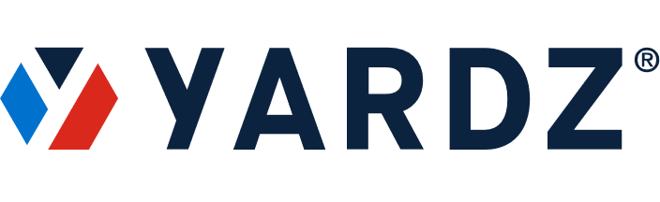
NEWS – FOR IMMEDIATE RELEASE
Media Contact:
Tammy Parham
YARDZ
919.275.2206
tparham@yardz.com

YARDZ CEO: “INFRASTRUCTURE BILL WILL BE BOON TO CONSTRUCTION FIRMS THAT ARE PREPARED FOR IT”

Developer of Industry’s Premier Asset Tracking Platform Advises Companies to Get Their
Equipment Management Systems in Order – or Pay the Price

ATLANTA, GA (August 10, 2021) – For even the most modern construction companies and general contractors, keeping track of their rented and owned equipment is a job that still seems to reside in the Middle Ages.
Often, they use antiquated methods like whiteboards and sticky notes. Some use Excel spreadsheets, which are a little further up the tech ladder, but equally inefficient. A few might use off-the-shelf software solutions that offer a bit more functionality but were not created to handle the nuances and specialized requirements of construction equipment management.
The result is that many of these companies don’t have a handle on the true status of their owned and rented assets. This leads to myriad problems: financial loss from overdue or duplicate rentals; missed project deadlines from incorrect equipment allocation; unnecessary wear and tear on owned machinery due to overlooked maintenance schedules - and the list goes on.
The consequences of this inefficiency can be significant. One of the most frustrating is duplicate rentals - renting a piece of machinery you already have. A piece of machinery that may be sitting on a job site somewhere, unused. Or even on your own lot, buried under fallen foliage.
With this unsettling scenario as a backdrop, here comes the government Infrastructure Bill put forth by the U.S. government. The $1 trillion bill – on which the final Senate vote will likely happen Tuesday, before moving to the House - calls for everything from “broadband and bridges to ports and pedestrian crossings, plus proposals for how to pay for it all.”
(MORE)

Infrastructure Bill / 2

Regardless of what the bill looks like in its final form, one thing is certain: there is going to be a massive increase in construction projects over the next decade and beyond. Companies lucky enough to be selected to handle this tsunami of building and repair will need to be highly organized in regard to their equipment management and inventory tracking; if not, they will find themselves saddled with monetary losses, decreased productivity, trouble completing projects, and the wrath of whichever agency hired them.
Jason Perez knows this better than anyone. A veteran of the construction industry, he and his partner Josh Schuyler saw a massive vacuum, in which people were using manual inventory management processes that technology could solve. In response, they created YARDZ, the most powerful software platform for tracking rental and owned equipment. Using this intuitive tool, companies can better understand exactly what they have in their inventory, reducing duplicate rentals and keeping close track of all equipment contracts and their provisions, as well as maintenance and warranty information for owned equipment. The result is significant savings in both time and money, as well as an increase in overall productivity.
But whether they use his product or not, Perez contends that without a way to effectively manage equipment inventory, construction companies and general contractors involved in any of the projects that spring from the infrastructure bill will find themselves in an unenviable – and potentially precarious – position.
“When you don’t have a solid method for tracking your equipment inventory, even under normal circumstances, you’re throwing money out the window,” he warned. “Whether it’s overdue rentals, sending a piece of equipment to a job that’s already there, or just slowing down your overall productivity, you’re taking a huge financial hit.
“Now let’s say your firm takes on one, two, maybe a dozen new projects through the infrastructure bill. Your lack of inventory management is going to become even more apparent, and your problems are going to be compounded.”
Even if your firm is in relatively good shape in terms of equipment tracking, taking on a couple of elaborate government projects could be the proverbial straw that breaks the camel’s back.
(MORE)

Infrastructure Bill / 2

“Maybe you’ve been able to somehow slide by with whiteboards, notepads, spreadsheets, and some other homegrown solutions,” he said. “The addition of even one major government project might expose your fragile inventory management system, and now you’re in deep water.”
Perez’s advice? Get your equipment management house in order – fast.
“The infrastructure bill is going to create a significant amount of construction across the country that, frankly, is long overdue,” he said. “Construction companies are going to benefit greatly from this boom – but only the ones that are internally prepared to take it on.”

ABOUT YARDZ
Founded in 2018 by construction and technology veterans Jason Perez and Josh Schuyler, YARDZ offers the most powerful software for tracking rental and owned equipment. The YARDZ tool helps companies better understand exactly what equipment they have in their inventory and where it’s located. This saves time and money by eliminating duplicate rentals; displaying all equipment contracts and their provisions; and ensuring that available equipment is sent to the jobs where it is needed most. While originally intended for construction companies and crews, it is adaptable to a wide range of vertical markets. Suppliers who use YARDZ can also build stronger relationships with contractors and gain more rental business. Flexible pricing and multiple product versions make YARDZ applicable for companies of all sizes.
###

