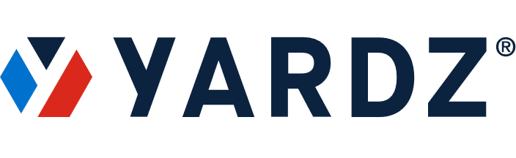
NEWS – FOR IMMEDIATE RELEASE
Media Contact:
Tammy Parham
YARDZ
919.275.2206
tparham@yardz.com
YARDZ ANNOUNCES APPOINTMENT
OF NEW CHIEF OPERATING OFFICER

Rental Equipment Industry Veteran Westley Parks Will Help Manage Strategic Partnerships, Interface With Key Accounts

ATLANTA, GA (June 24, 2021) – Jason Perez, CEO of YARDZ, makers of the premier independent rental management tool in construction, announced that Westley Parks has been named Chief Operating Officer of the company.
As COO, Parks will hold a number of responsibilities, including management of all YARDZ strategic partners. He will also work closely with the YARDZ sales team and will interface with key customer accounts.
Parks is a 35-year veteran of the equipment rental industry and the former Chief Operating Officer of Neff Rental. As COO, he was an integral part of Neff’s growth and expansion, and eventual sale to United Rentals, where he served as a Region Vice President until early 2019.
Parks began his career at Hertz Equipment Rental. He joined Neff in 1995 as Southeast Region Manager. In 1998, he was promoted to Atlantic Region Vice President, a position he held for 17 years before assuming his COO role.
Perez will rely on Parks’ extensive industry experience to help guide the company’s strategic expansion.
“You don’t find people with Westley’s breadth of experience just growing on trees,” said Perez. “His knowledge, industry connections, and vision are unparalleled. We expect him to be an integral part of the ambitious growth plan we’ve mapped out to increase our customer satisfaction while spreading the Yardz message to new prospects.”
(MORE)

YARDZ Names Wes Parks as New COO / 2

A 1984 graduate of the University of Georgia, Parks hold a degree in advertising. He lives in Camden, SC, with his wife Laurie.
YARDZ is an Atlanta-based, construction tech company that helps companies manage their inventory of both owned and rental equipment more efficiently. Utilizing an intuitive and user-friendly interface, the YARDZ integration and collaboration tool is completely brand-agnostic, allowing customers to connect to their rental companies as well as see their own equipment yards all in one place.
ABOUT YARDZ
Founded in 2018 by construction industry veterans Jason Perez and Josh Schuyler, YARDZ offers the most powerful software for tracking rental and owned equipment. The YARDZ tool helps companies better understand exactly what equipment they have in their inventory and where it’s located. This saves time and money by eliminating duplicate rentals; displaying all equipment contracts and their provisions; and ensuring that available equipment is sent to the jobs where it is needed most. While originally intended for construction companies and crews, it is adaptable to a wide range of vertical markets. Suppliers who use YARDZ can also build stronger relationships with contractors and gain more rental business. Flexible pricing and multiple product versions make YARDZ applicable for companies of all sizes.
###

