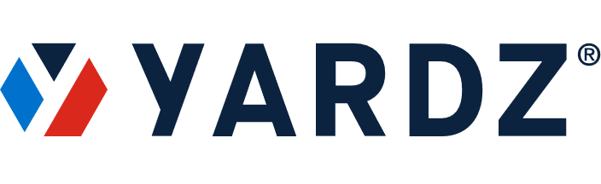
NEWS – FOR IMMEDIATE RELEASE
Media Contact:
Tammy Parham
YARDZ
919.275.2206
tparham@yardz.com

YARDZ TECHNOLOGY PLATFORM PROVIDES MOST EFFICIENT MANAGEMENT OF OWNED AND RENTED ASSETS

Helps Construction Companies, General Contractors and More Keep Track
Of All Equipment Inventory Accurately and Cost-Effectively

ATLANTA, GA (August 1, 2021) – Spreadsheets and whiteboards.
These are the tools construction companies have traditionally used to manage their inventory of rented and owned equipment. Needless to say, inefficiency is often the result. Machinery is lost or unaccounted for, time is wasted tracking it down, data entry is time-consuming – and if someone accidentally erases a whiteboard, forget it.
The consequences of this inefficiency can be significant. One of the most frustrating is duplicate rentals - renting a piece of machinery you already have. A piece of machinery that may be sitting on a job site somewhere, unused. Or even on your own lot, buried under fallen foliage.
Jason Perez and Josh Schuyler saw a massive vacuum, in which people were using manual processes that technology could solve. As a result, they created YARDZ, the most powerful software platform for tracking rental and owned equipment. Using the product, companies can better understand exactly what they have in their inventory, reducing duplicate rentals and keeping close track of all equipment contracts and their provisions. The result is dramatic savings in both time and money.
YARDZ provides myriad benefits for users of both rented and owned equipment. On the rental side, YARDZ allows contractors to see, in one place, all their assets in the field; the location of each piece of machinery; payment terms; and the date each item is due back at the supplier. As a result, users can ensure that available equipment is sent to the jobs where it’s needed most.
(MORE)
YARDZ Equipment Management Tool / 2

The system also offers one-click call offs (calling rented equipment off on time is an area of huge potential savings), as well as alerts and inventory summaries.
For owned equipment, YARDZ provides the same high level of management functionality but includes additional features such as the ability to track and schedule equipment maintenance, as well as keeping an eye on warranty information.
While originally intended for construction companies and crews, it is adaptable to a wide range of vertical markets, including Aircraft Manufacturing, Farming, Utilities, Railroads, Forestry, Landscaping, Logging, Mining, and Shipping.
Suppliers who use YARDZ can also build stronger relationships with contractors and gain more rental business. Yardz provides four different versions of its software: Pro, Corporate, Enterprise, and Enterprise Plus. Flexible pricing and multiple product versions make YARDZ applicable for companies of all sizes.
“Our goal was to give construction renters and asset managers their time back and technology that not only benefited their workday but saved money for their businesses and looked out for their bottom line,” explained Perez, CEO of YARDZ. “We wanted to help move industry professionals away from whiteboards and spreadsheets and ‘into the future.’
While there are a few competitive products in the field, there is no other platform with the level of functionality that YARDZ provides.
“There is literally no parameter that YARDZ does not keep track of both on the rented and owned equipment side,” Perez emphasized. “The beauty is that our customers are constantly finding new ways to use it, ways we hadn’t even thought of. The product’s benefits are constantly evolving.”
###

