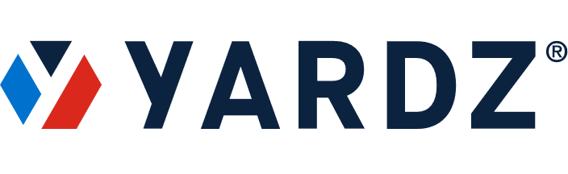
NEWS – FOR IMMEDIATE RELEASE
Media Contact:
Josh Schuyler
YARDZ
470.239.0596
josh@yardz.com

KRAKEN COMMUNICATIONS TAKES GIANT STEP INTO
ASSET MANAGEMENT WITH YARDZ PLATFORM

Fiber Broadband Infrastructure Specialist Will Use YARDZ to
Manage, Track, and Maintain Truck Fleet and Equipment

ATLANTA (February 15, 2024) – YARDZ, the premier tool for managing owned and rented assets in the construction industry, announces that Kraken Communications, LLC, a Utah-based, fiber broadband installation contractor, has signed on to the YARDZ platform.
Kraken invested in a YARDZ corporate plan, which allows for 10 user licenses. While Kraken will initially deploy YARDZ for basic needs such as fleet management and maintenance, as well as tracking their extensive inventory of job-related equipment, the company intends to eventually access the complete YARDZ feature suite. Consequently, Kraken can “grow into” the product, adding capabilities like telematics when the time is right.
While Kraken occasionally rents assets from rental industry giants like United and Sunbelt, the overwhelming majority of the trucks and equipment they will be managing are owned by the company.
Kraken Communications leverages its expertise in fiber broadband to build and upgrade fiber-optic networks, expanding the reach of high-speed internet and empowering communities to thrive in the digital age.
“We’re excited to implement the YARDZ platform,” said Ethan Medeiros, General Manager at Kraken. “As a relatively new and growing company, we knew we needed to develop a comprehensive asset management plan. YARDZ allows us to do that cost-effectively with all the features we need – now and well into the future.”
(MORE)
Kraken Signs on to YARDZ Platform / 2

According to Jason Perez, CEO of YARDZ, Kraken represents the ideal entry customer on several fronts.
“Frankly, we see this as a great fit for Kraken’s situation,” he explained. “If they had just opened their business, they might be hesitant to commit to purchasing any software. Now that their doors have been open for a little over a year, they’re starting to feel some of the pain points that an asset management program like YARDZ was built to solve.
“Combine that with Kraken’s leadership, who are savvy enough to realize they need a tool like YARDZ to really move the company forward. It’s perfect for Kraken, and we get a customer that we can help grow over time.”
ABOUT KRAKEN COMMUNICATIONS LLC
Based in Orem, Utah, Kraken Communications leverages its expertise in fiber optics to build and upgrade networks, expanding the reach of high-speed internet and empowering communities to thrive in the digital age. The company utilizes cutting-edge broadband fiber technology and innovative construction techniques like micro trenching for faster installation with minimal disruption. Kraken is committed to bridging the digital divide and providing essential internet access for work, education, healthcare, and more.
ABOUT YARDZ
Founded in 2018 by construction industry veterans Jason Perez and Josh Schuyler, YARDZ offers the most powerful software for tracking rental and owned equipment. The tool helps companies better understand exactly what equipment they have in their inventory and where it’s located. This saves time and money by eliminating duplicate rentals; displaying all equipment contracts and their provisions; and ensuring that available equipment is sent where it is needed most. While originally intended for construction companies and crews, it is adaptable to a wide range of vertical markets. Suppliers who use YARDZ can also build stronger relationships with contractors, gaining more rental business.
###

